Defect / Bug Report
Defect tracking using Jira.

Defect 1
Defect ID: BRK-001
Title: Cart API returns error when updating product quantity
Module: Cart
Environment:
- Website: https://breakout.com.pk
- Browser: Google Chrome
- Tool: Postman
- OS: Windows 10
Pre-condition:
- User has a product added to cart
Steps to Reproduce:
- Open Postman
- Send POST request to https://breakout.com.pk/cart/update.js
- Pass product variant ID in request body
- Click Send
Expected Result:
- Cart should update successfully
- API should return updated cart details with 200 OK
Actual Result:
- API returns 422 Unprocessable Content
- Error message: "Cart Error"
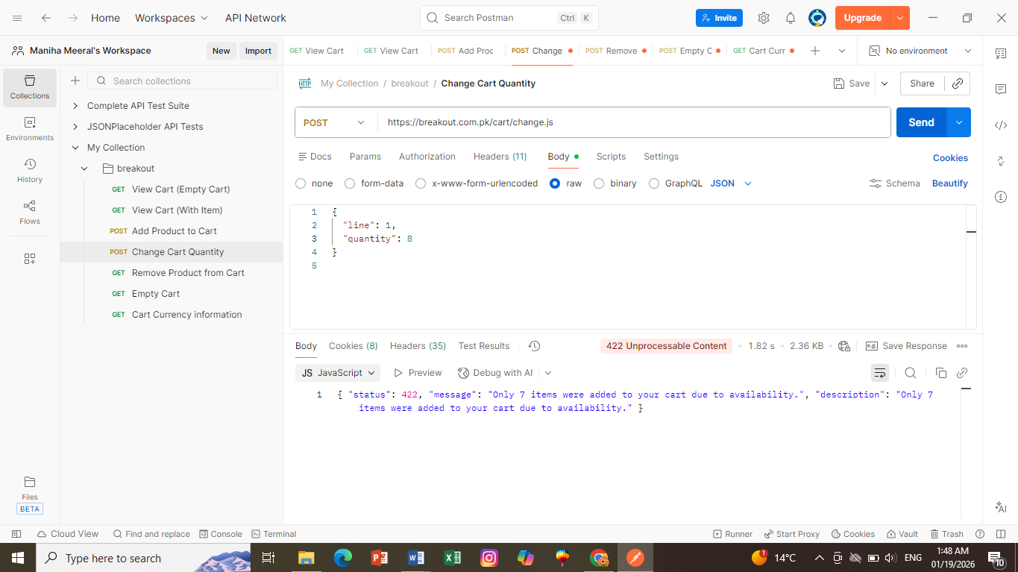
Status: Open
Severity: Medium
Priority: High

Defect 2
Defect ID: BRK-002
Title: Cart API allows empty cart response without user warning
Module: Cart
Environment:
- Website: https://breakout.com.pk
- Browser: Google Chrome
- Tool: Postman
- OS: Windows 10
Pre-condition:
- Cart is empty
Steps to Reproduce:
- Send GET request to https://breakout.com.pk/cart.json
- Observe response

Expected Result:
- API should return message like “Cart is empty”
Actual Result:
- API returns empty items array without message
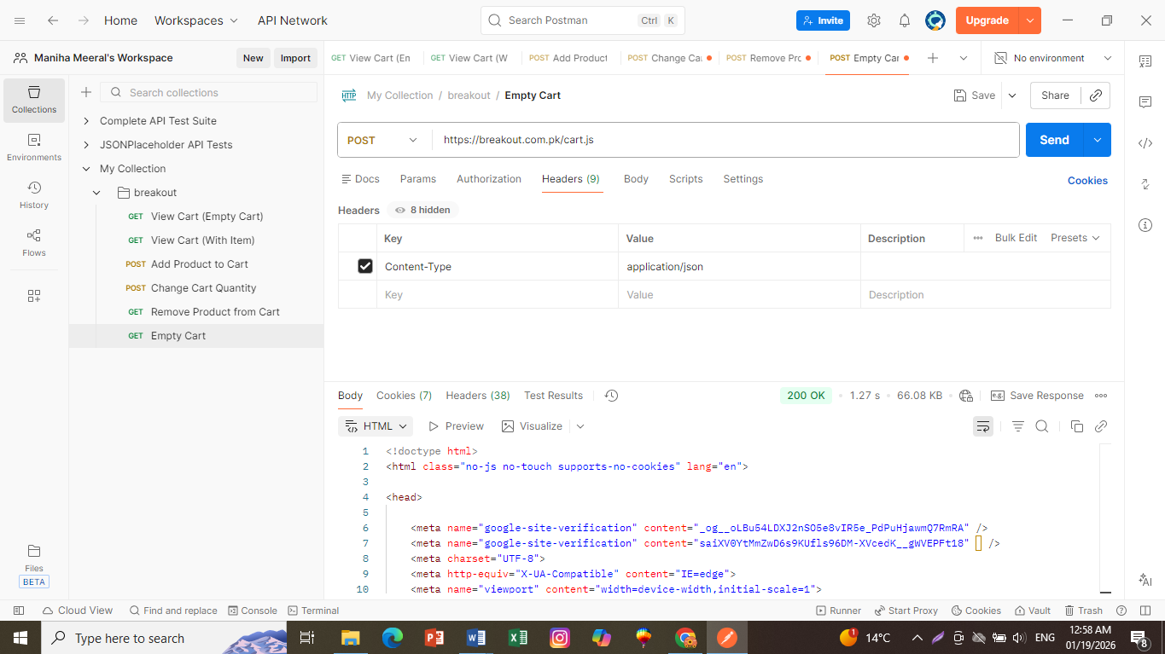
Status: Open
Severity: Low
Priority: Medium

Defect 3

Defect ID: BRK-003
Title: Add to Cart API allows adding product with invalid quantity
Module: Cart
Environment:
- Website: https://breakout.com.pk
- Browser: Google Chrome
- Tool: Postman
- OS: Windows 10

Steps to Reproduce:
- Send invalid payload in POST request
- Observe response message
Expected Result:
- API should reject invalid quantity
- Proper validation error message should be returned
Actual Result:
- API accepts invalid quantity or returns unclear error
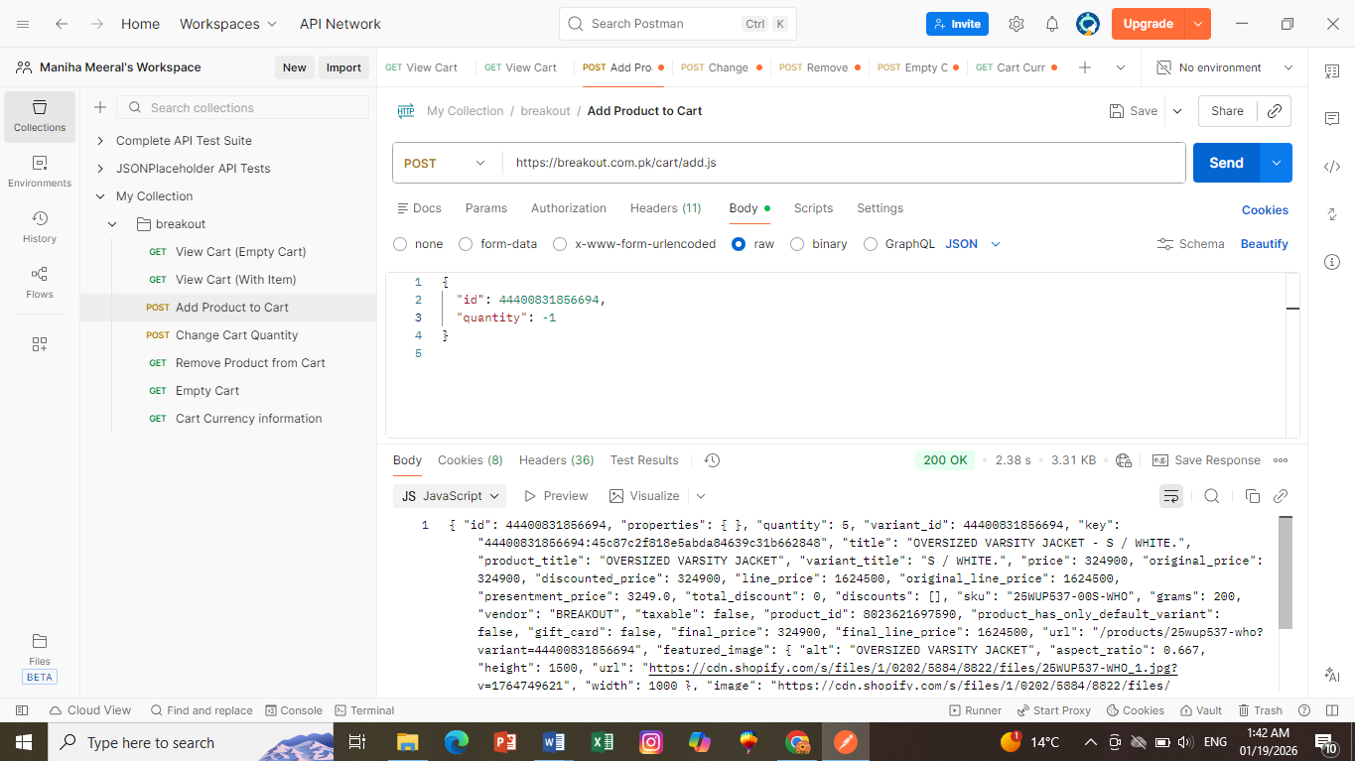
Status: Open
Severity: Medium
Priority: Medium

Defect 4

Defect ID: BRK-004
Title: Cart API response does not include currency information

Module: Cart
Environment:
- Website: https://breakout.com.pk
- Browser: Google Chrome
- Tool: Postman
- OS: Windows 10

Steps to Reproduce:
- Send GET request to /cart.json
- Observe response

Expected Result:
- API should clearly mention currency (PKR)

Actual Result:
- Currency is not explicitly mentioned in response
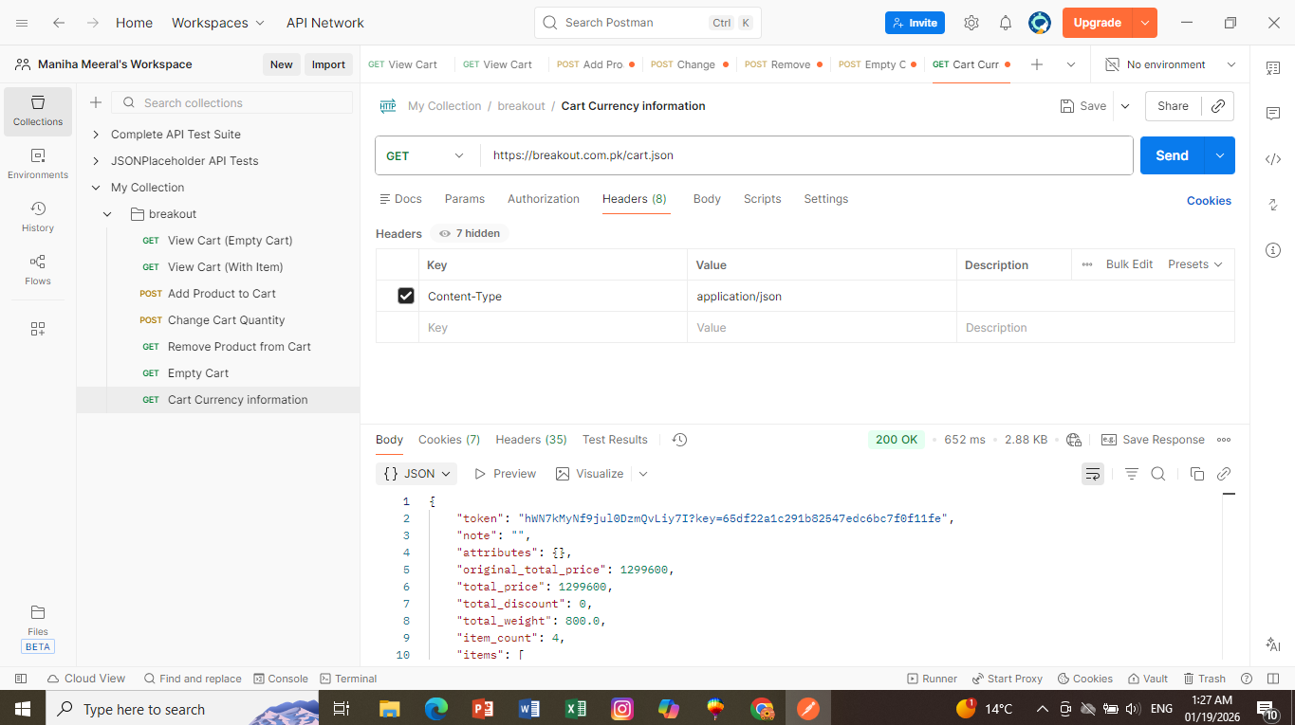
Status: Open
Severity: Low
Priority: Medium

Defect 5

Defect ID: BRK-005
Title: Cart API allows request without authentication context

Module: Cart
Environment:
- Website: https://breakout.com.pk
- Browser: Google Chrome
- Tool: Postman
- OS: Windows 10
Steps to Reproduce:
- Send invalid payload in GET request
- Observe response
Expected Result:
API should clearly define whether authentication is required or optional.

Actual Result:
API works silently using cookies without explicitly stating authentication behavior.
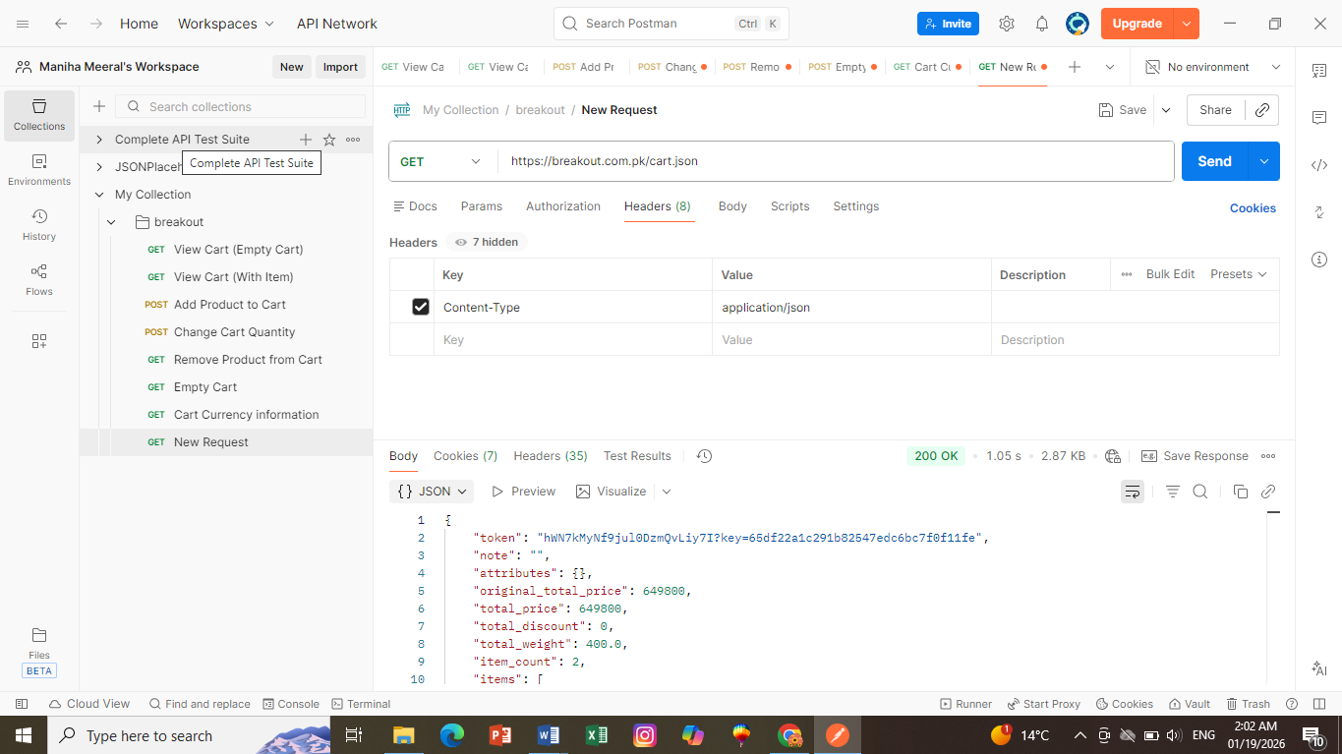
Status: Open
Severity: Low
Priority: Medium

